**Task 3 (B) :- Parallel Programming Basics**

We were given code for C language which basically prints the multiple threads on different core of the multicore machine. And we tried the different entrees also. The problem the code had in the first section was that int id was declare din main method. When we ran the code we saw that the id number is appearing more then once.

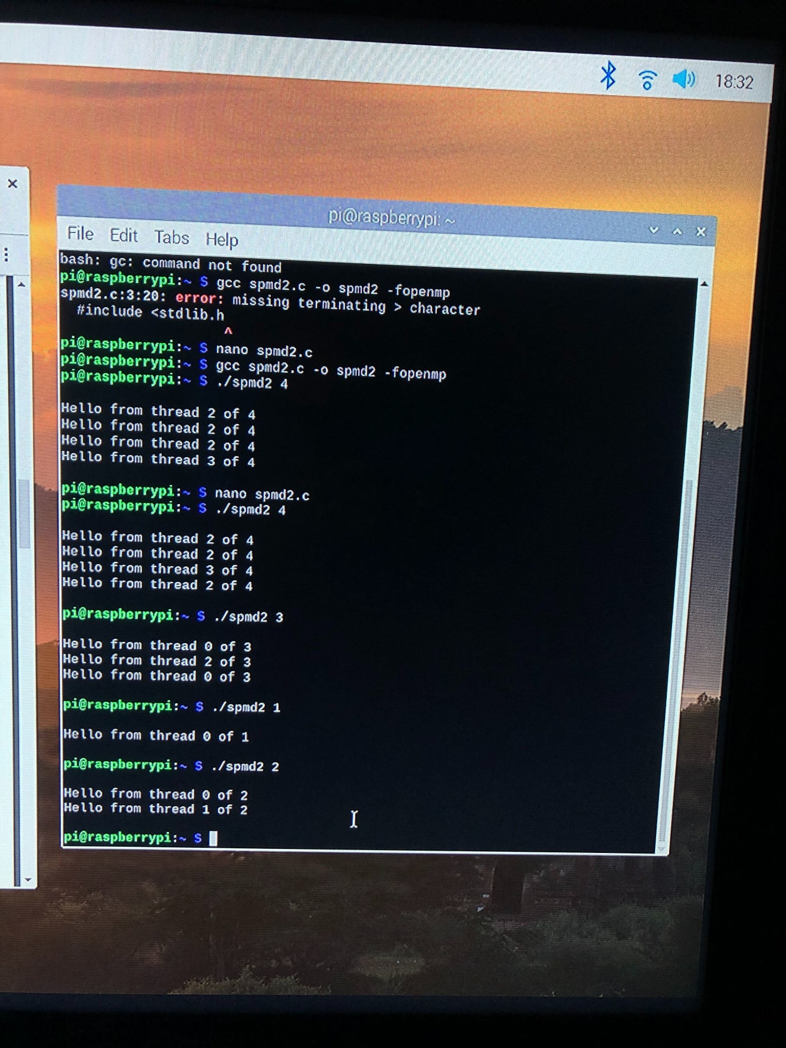

**Task 4: ARM assembler in Raspberry Pi**

**Part 1 - Second program**

After setting up the raspberry Pi on TV. I proceeded to follow the tasks to practice coding in ARM Assembler.



we wrote and saved the following program:

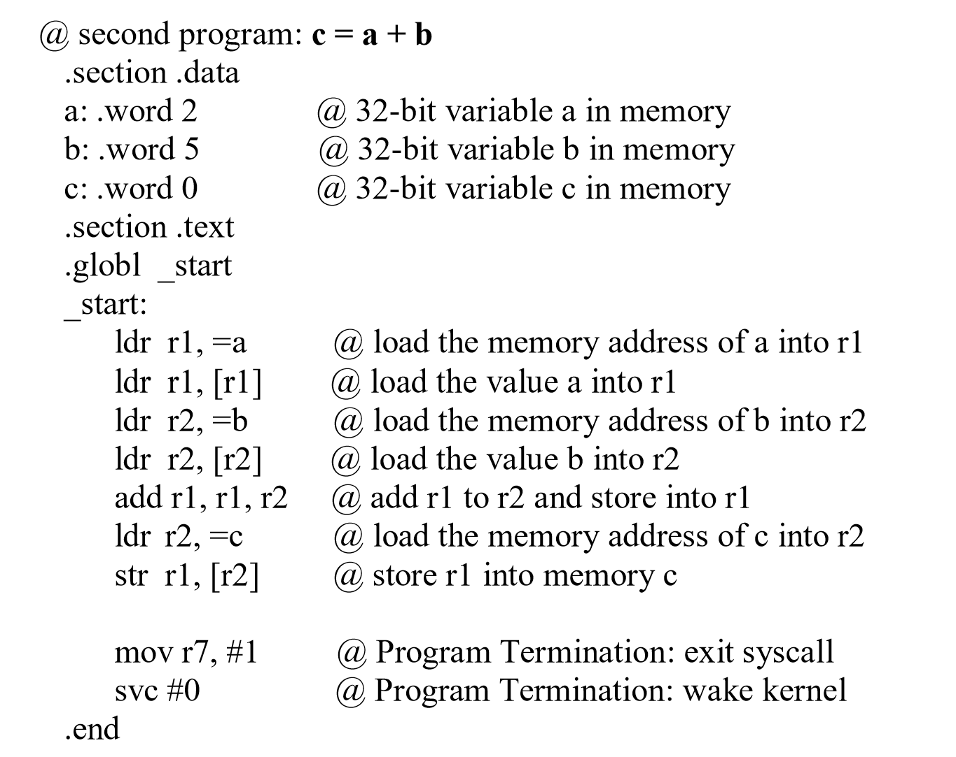

After composing the file, we then assembled and linked it in order the receive an executable file. Then we executed it. No output though. The entire program takes place in the registry, we will not receive any output.

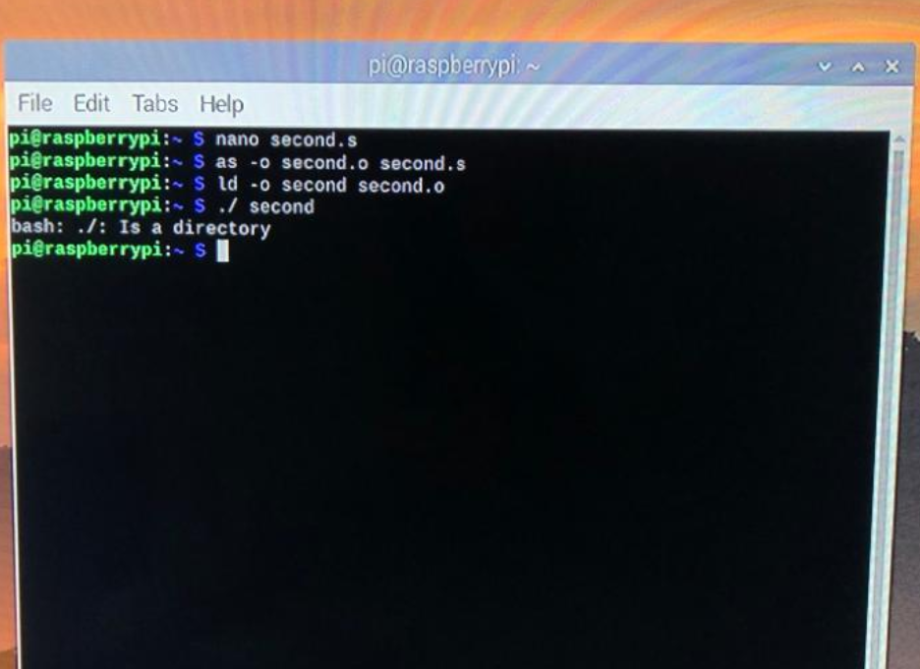

Next, we practiced utilizing the GDB (GNU DeBugger) in order to get an idea on how our First Program was being executed. Preparing to use the GDB required us to re-assemble the program with an additional flag “-g”. No additional steps were needed when the program was re-linked. After the new executable was generated, we launched the GDB with the particular file named “first” which we wished for the debugger to examine (utilizing “gdb first”).

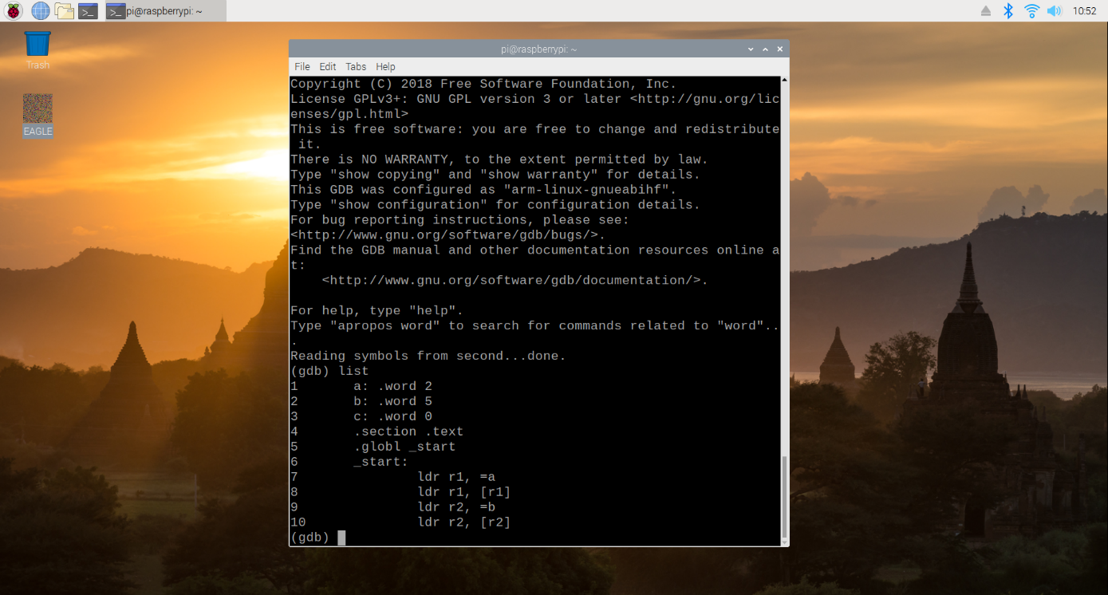

If the program already executes as expected, the debugger provides less information without an additional step, setting a breakpoint. We were able to see how the program was completing its tasks. To stop the program prior to the execution of line 15, we gave the GDB the command “b 15”, and then we ran the program from its beginning until the breakpoint utilizing “run”.

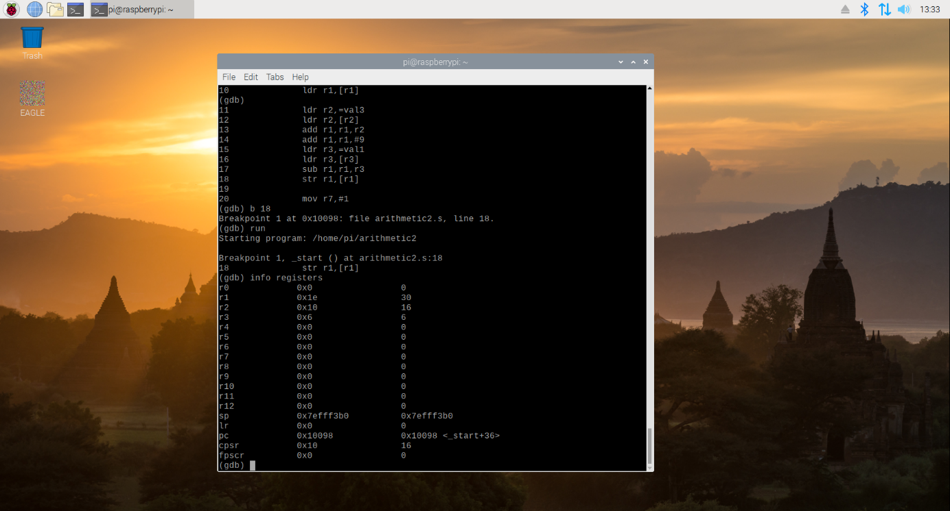

In order to see the generated values in the CPU registers (before line 15 was executed), we needed to utilize the command “info registers”. As we know the vales in the register a=2 b=5, c=0 then we build the program to run the code and ger results in c=a+b.

**Part 2 - Calculate the Expression**

With this better understanding of the process, we began Part 2 in which we created, assembled, linked, ran, and debugged our own program which calculated the expression Register = val2 + 9 + val3 – val1 where Val1=06, Val2=11, Val3=16.

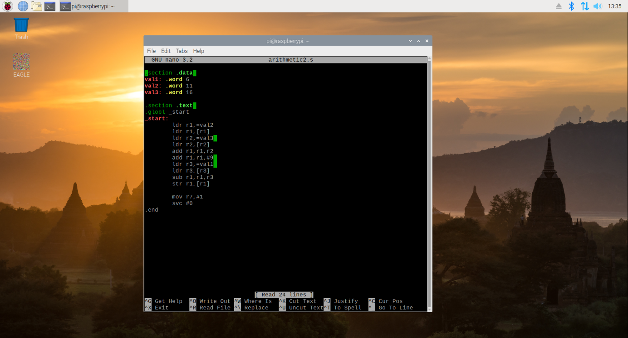

As in Part 1, we composed the program through the terminal with nano text editor, before assembling it. When composing a program, an extra, empty line must be included following the end of the program, or the assembler will take it upon itself to add the line for the user.

After assembly, we linked the program to create the executable file and ran that file.

For reference, the program we utilized was as follows:

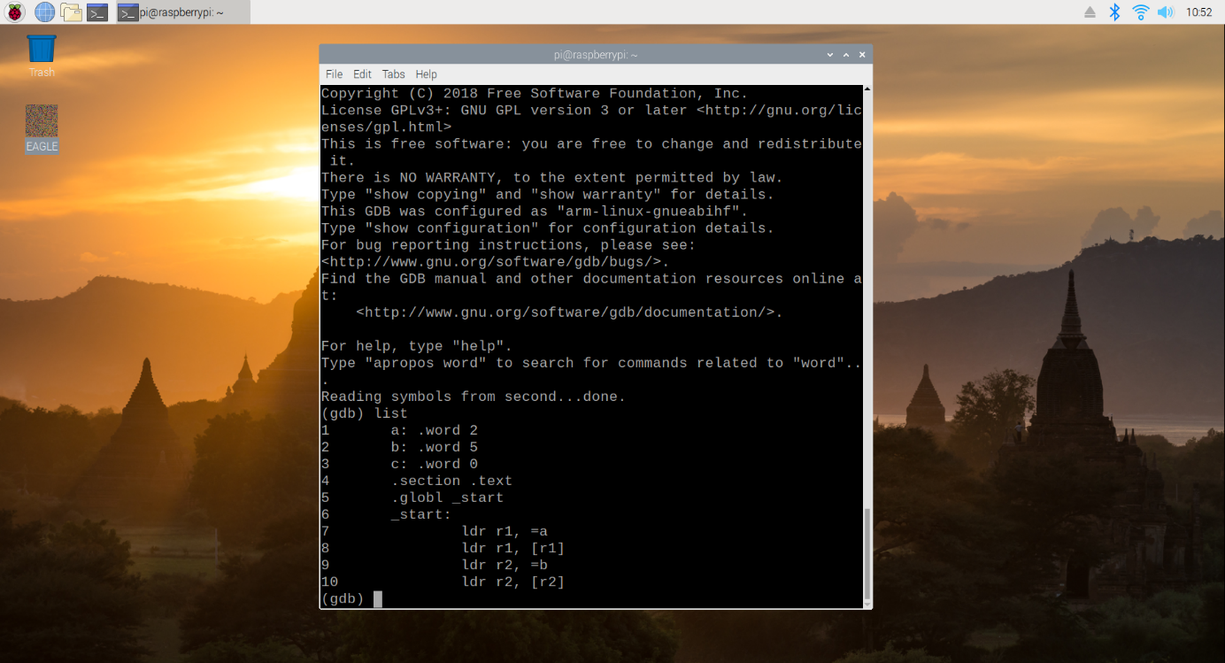

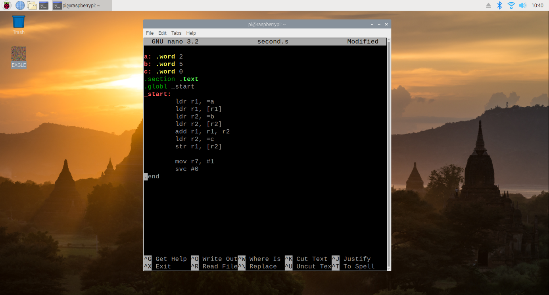

As with before, we were not able to “see” the program at work, so again we used the GNU Debugger so as to get a better idea of how our program was functioning.

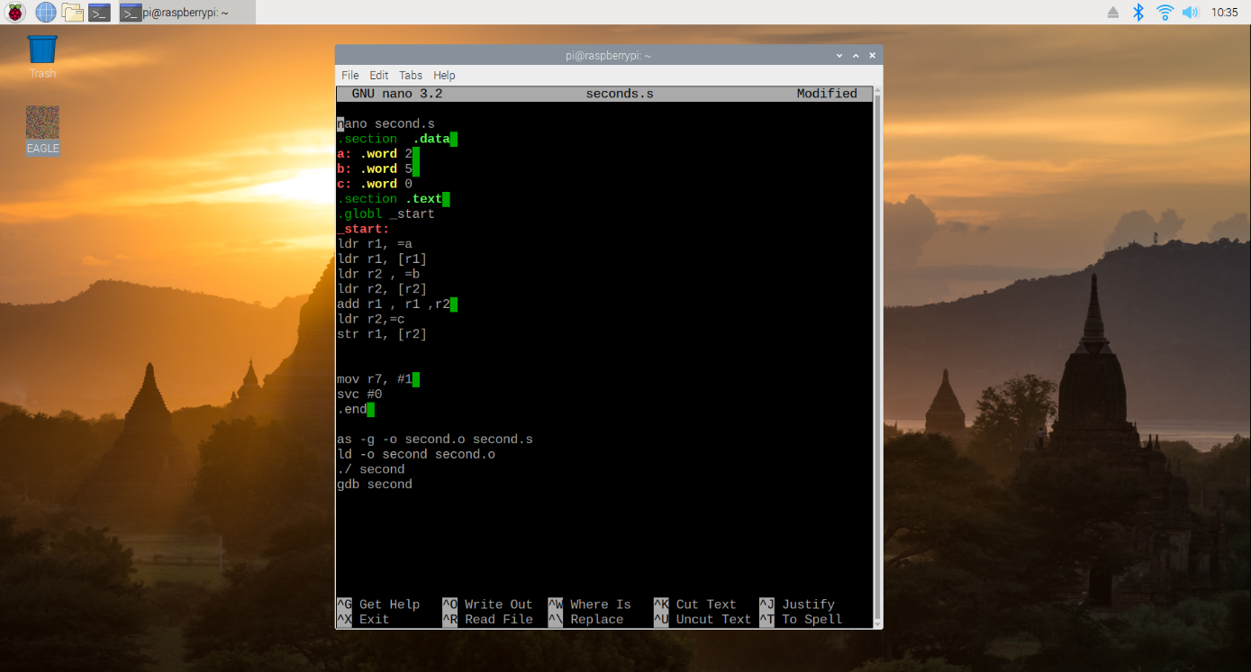

We then ran the program before utilizing the “info registers” command (whose results are shown in the next figure).

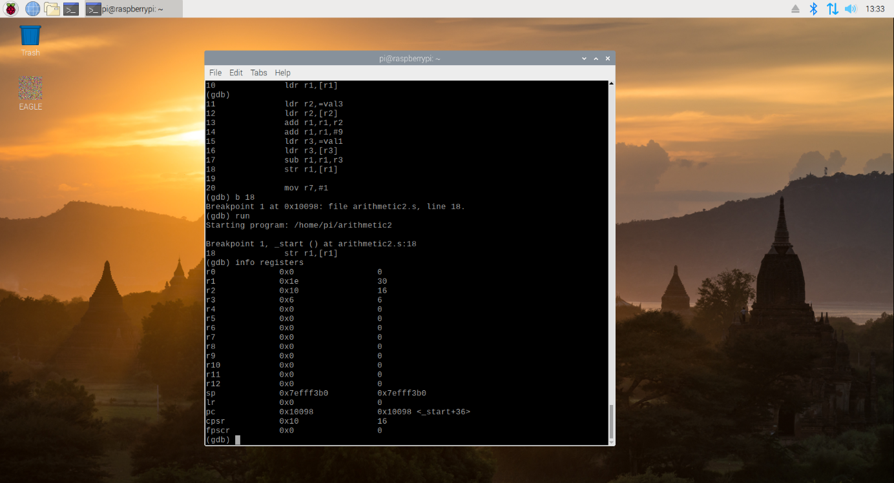

Comparing the values stored in the register, we could see that each of the values were expected. Registers 1 through 3 held the values 30, 16, and 6 which were their assigned values. Register 1 held the value of 30 - the result of our initial val2 + 9 + val3 – val1.